# ALE Issue Report v1.1 description

Contents

ALE Issue Report v1.1 description 1

Global Workflow : 2

Template as image. 3

“Main form” tab: 3

“Analysis Implementation” tab: 5

“Validation” tab: 6

“Peer Review/Deviations” tab: 6

“Relationships” tab: 6

“Attachments” tab: 6

“Customer Supplied Data” tab: 7

“Impact Analysis” tab: 7

“Issue Change Package Metrics” tab : 8

Simplified workflow : 9

List of **MANDATORY** attributes and when they must be entered and when they are visible: 10

List of **OPTIONAL (Visible)** attributes and when they must be entered and when they are visible: 12

List of **OTHER** attributes (Most are not used and not visible): 16

## Global Workflow :

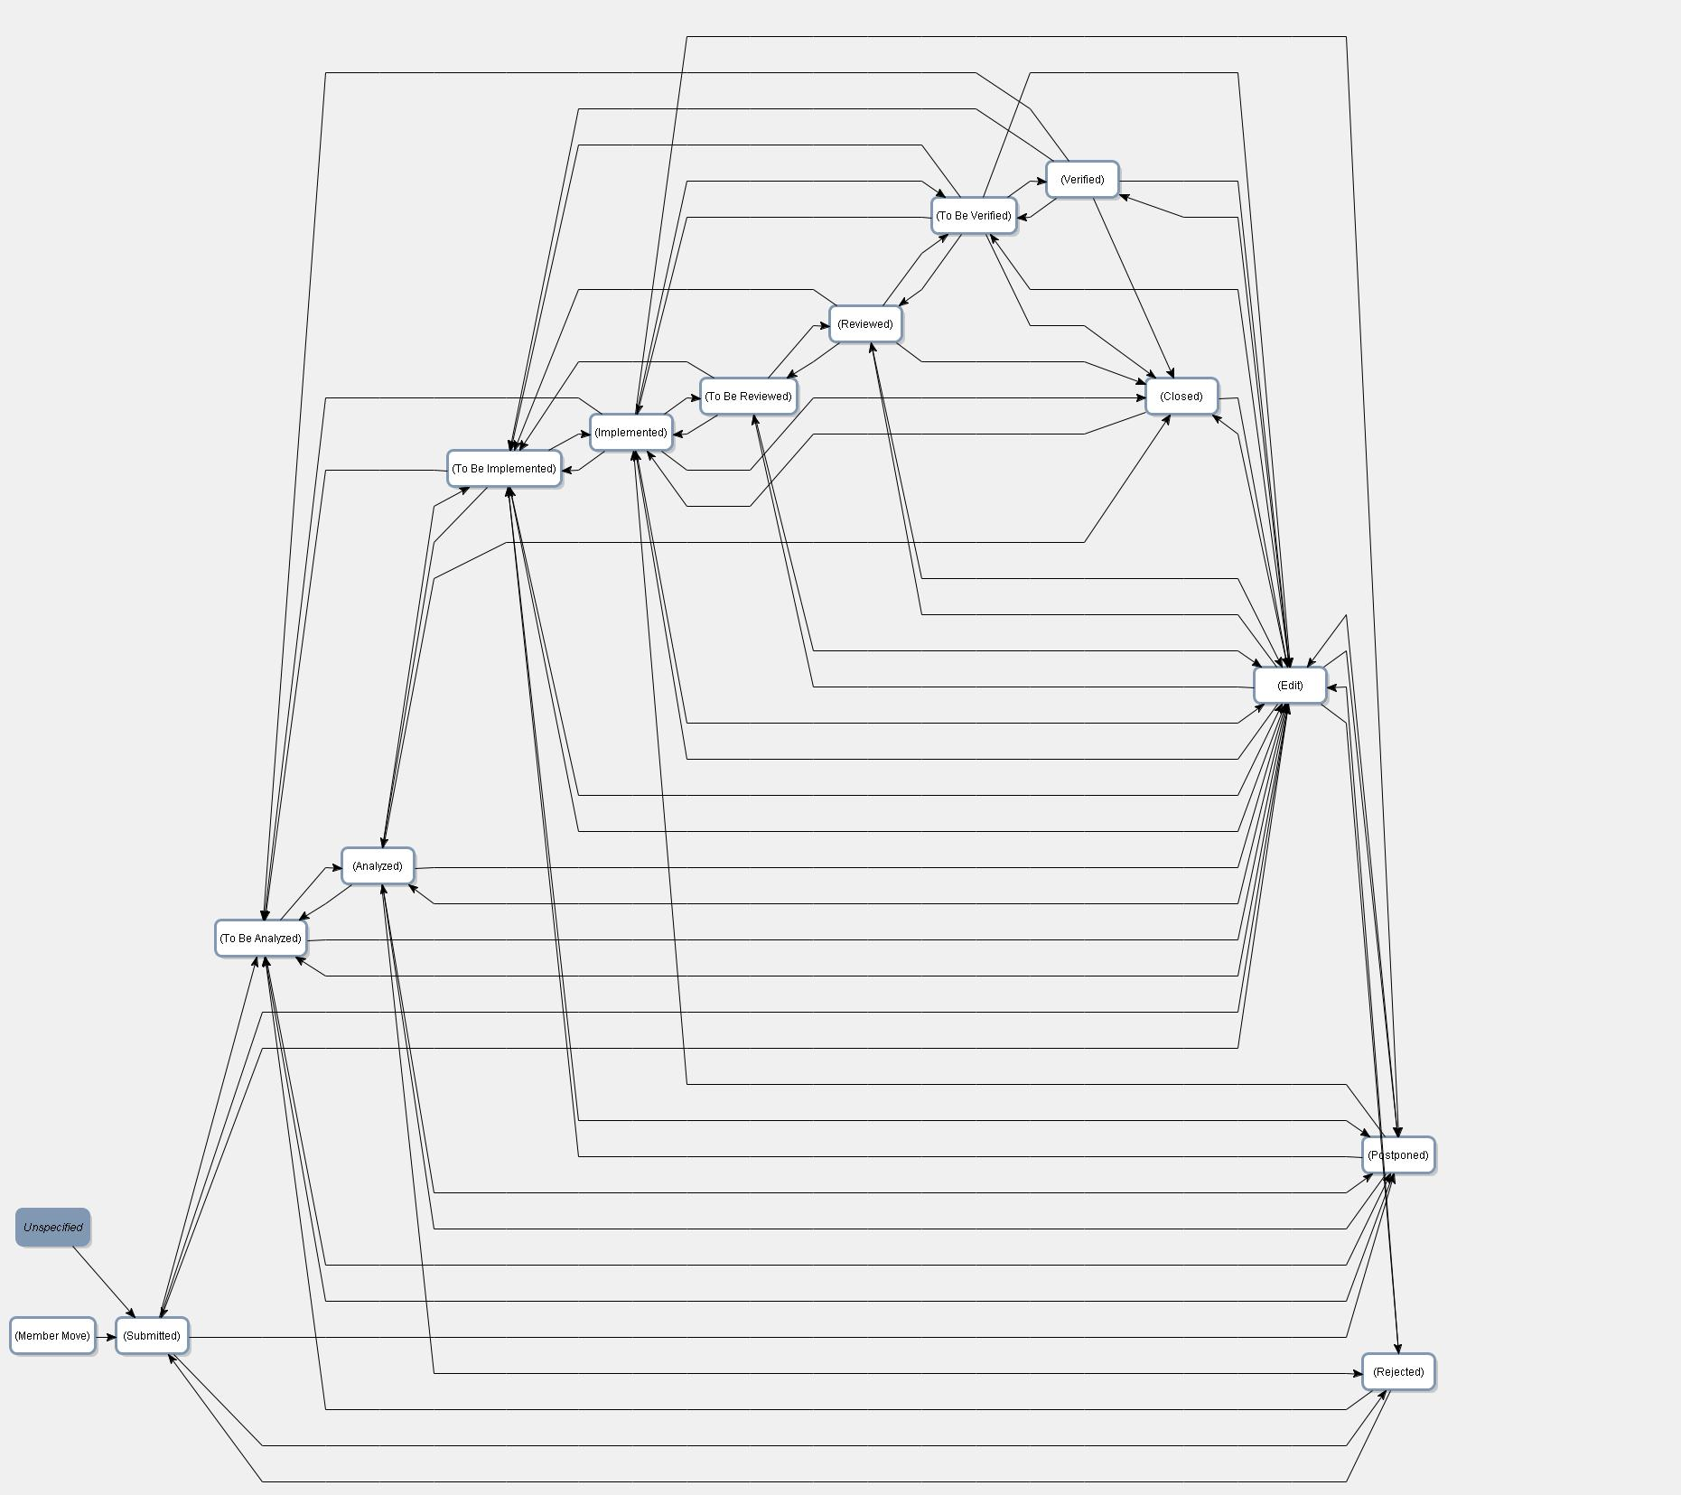

## Template as image.

### “Main form” tab:

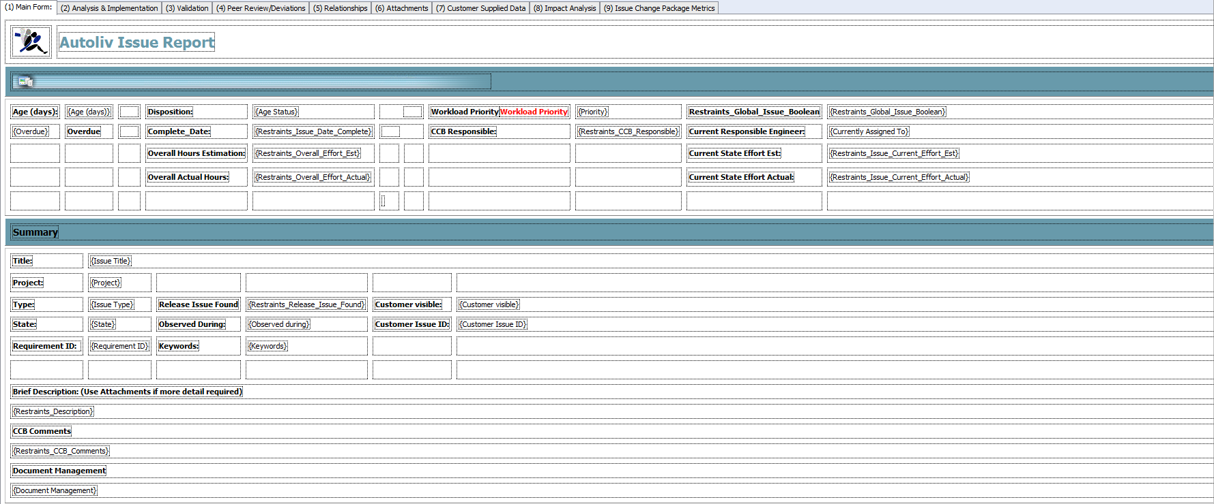

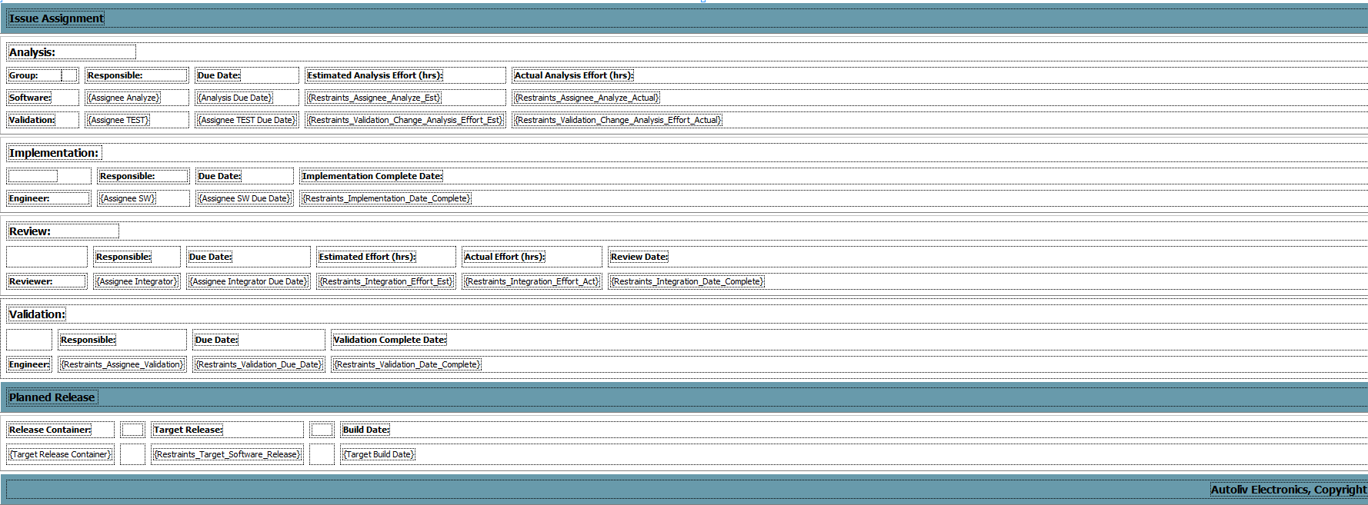

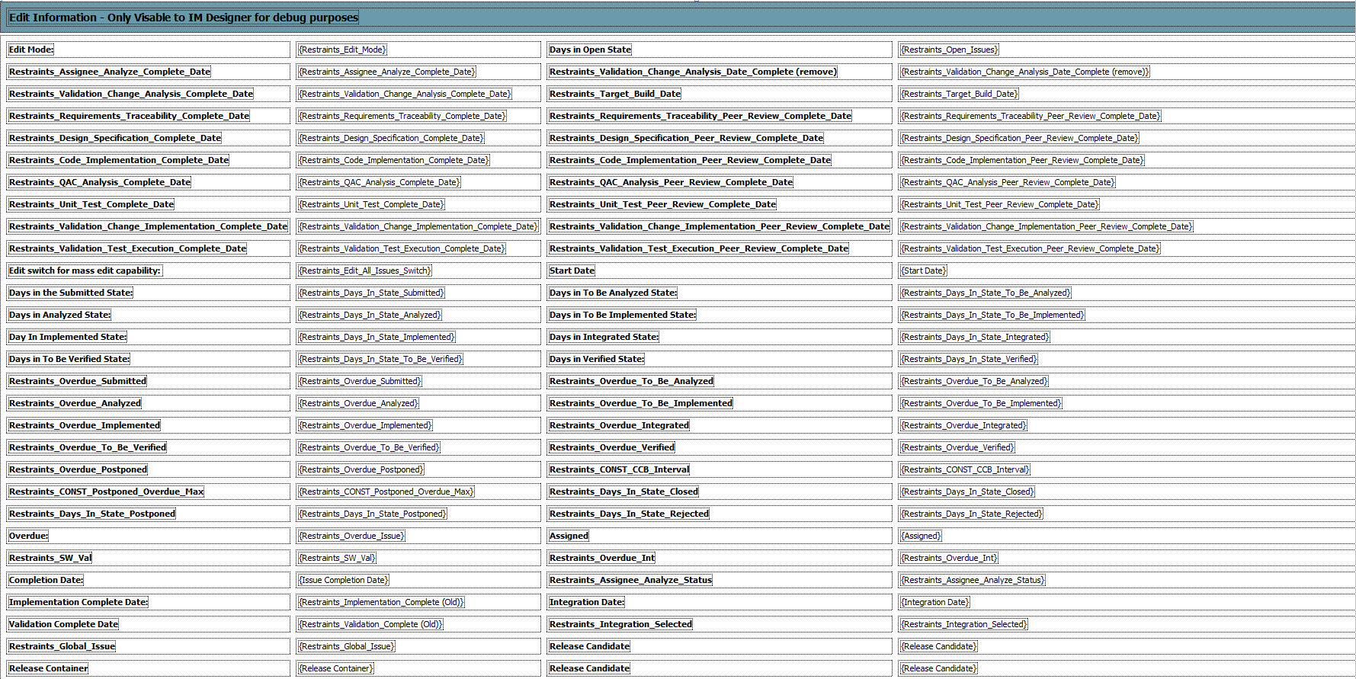

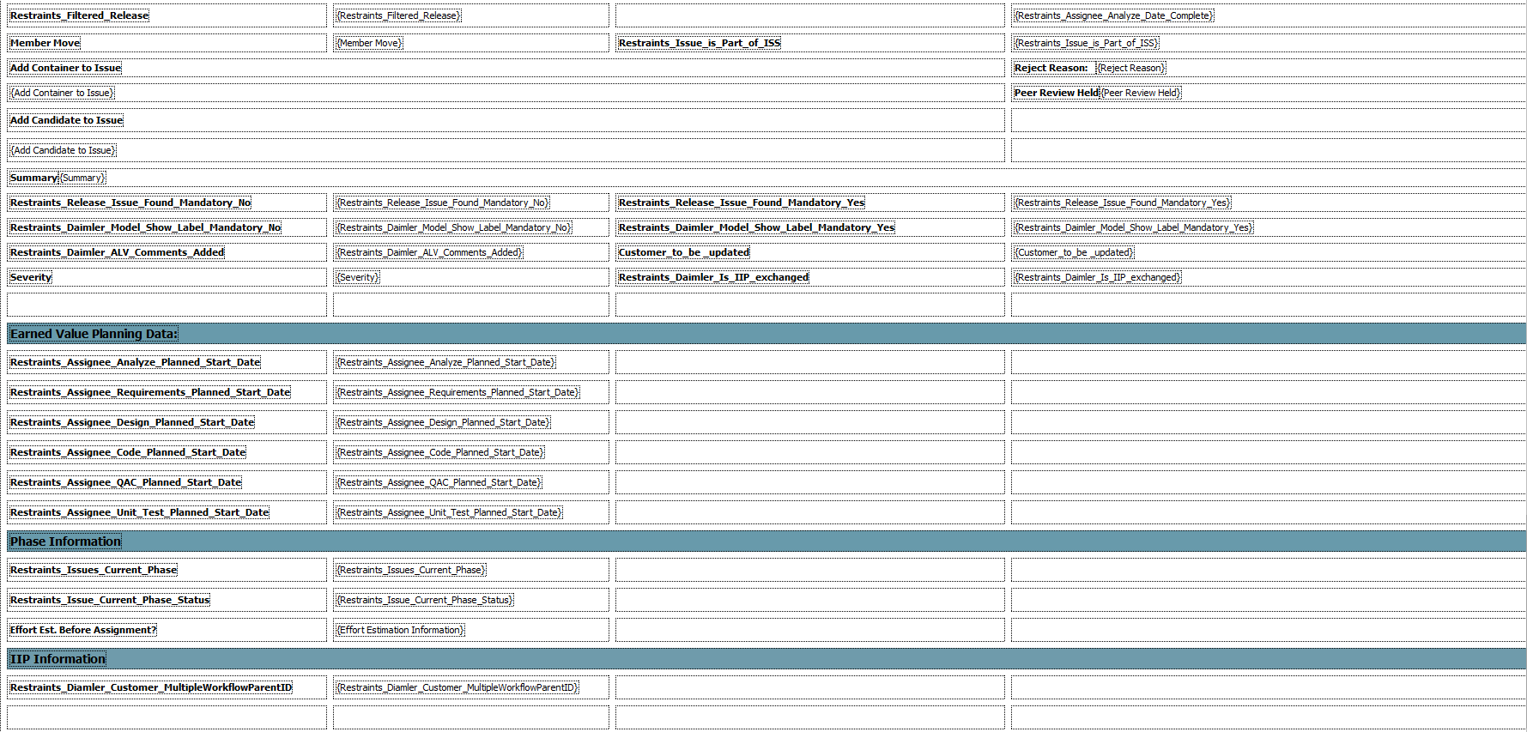

### “Analysis Implementation” tab:

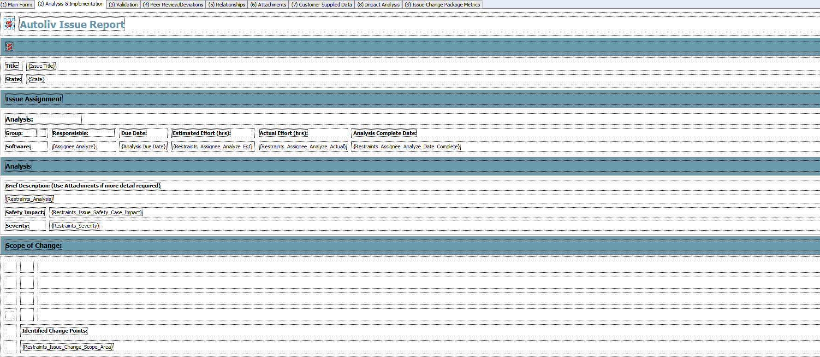

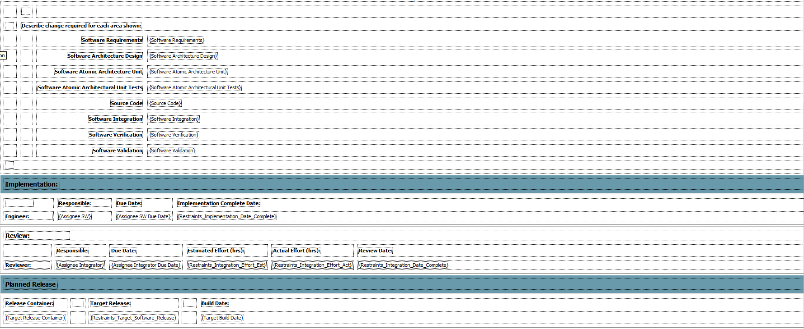

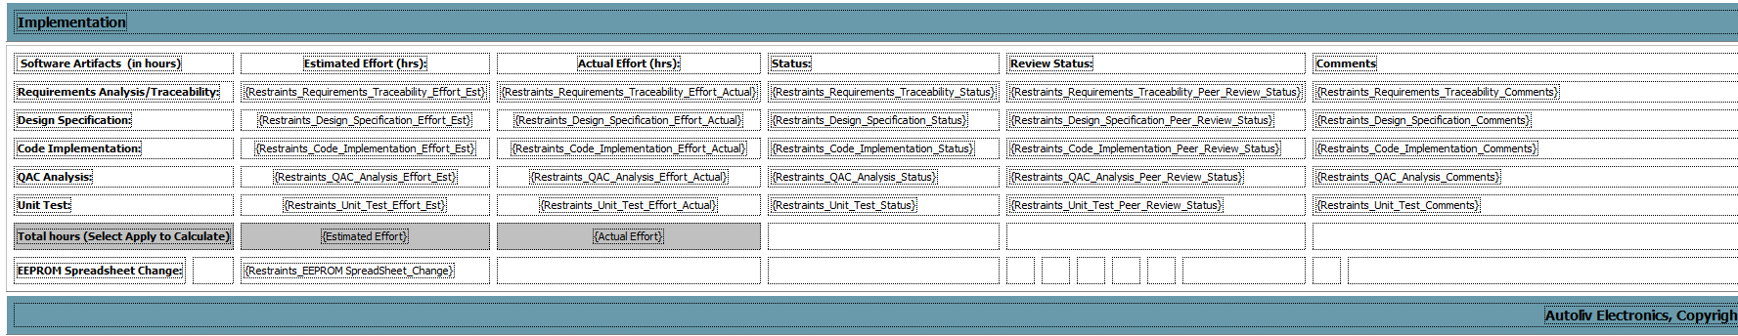

### “Validation” tab:

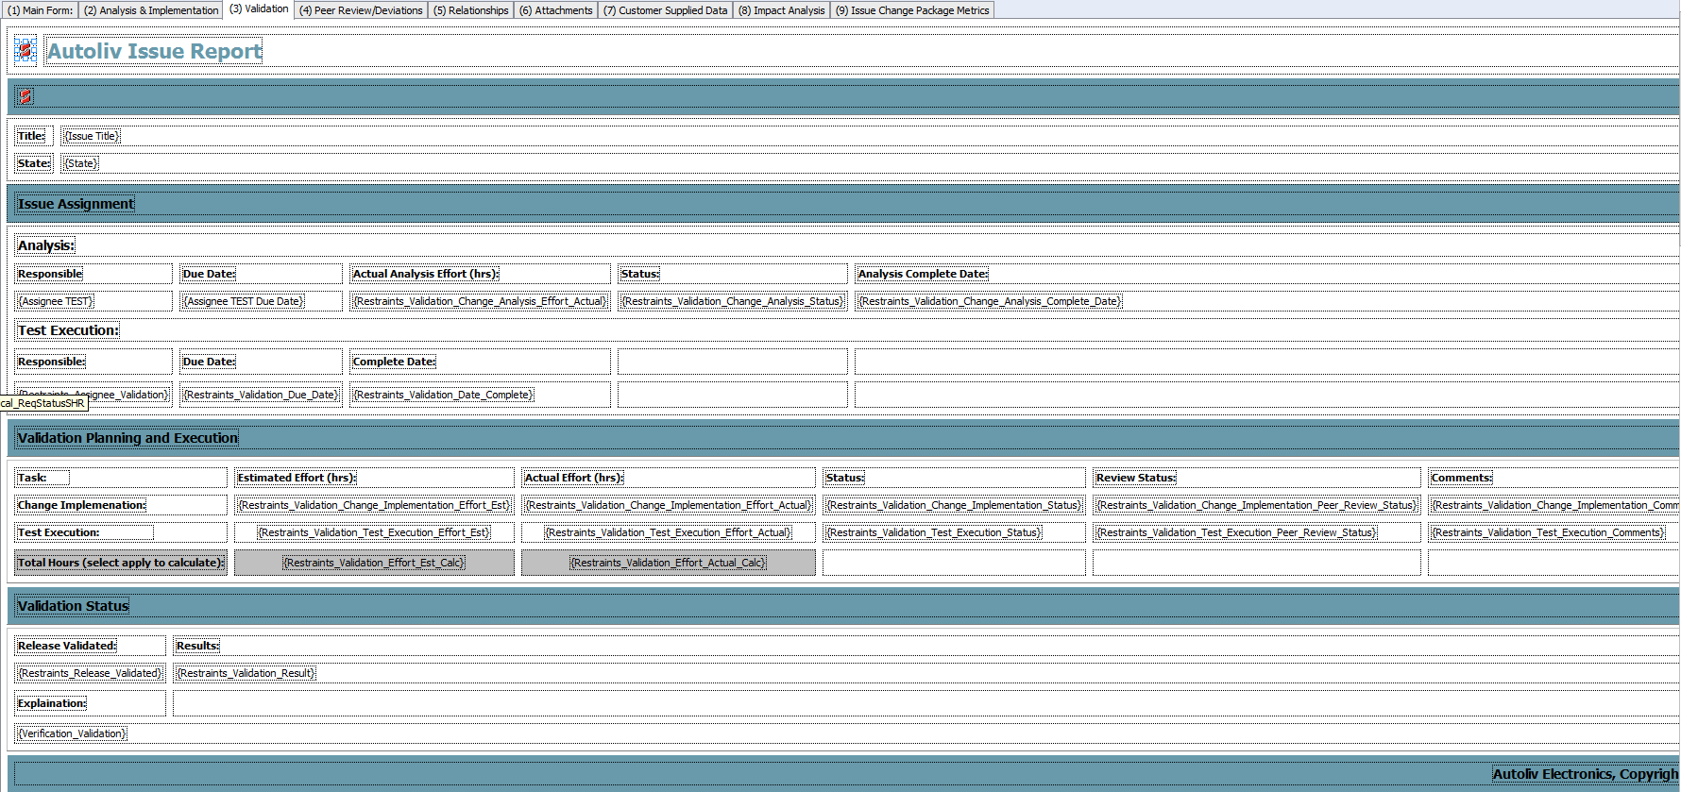

### “Peer Review/Deviations” tab:

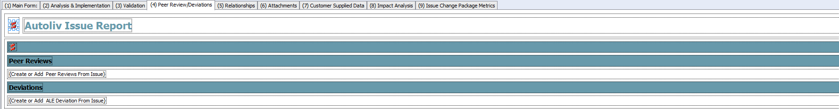

### “Relationships” tab:

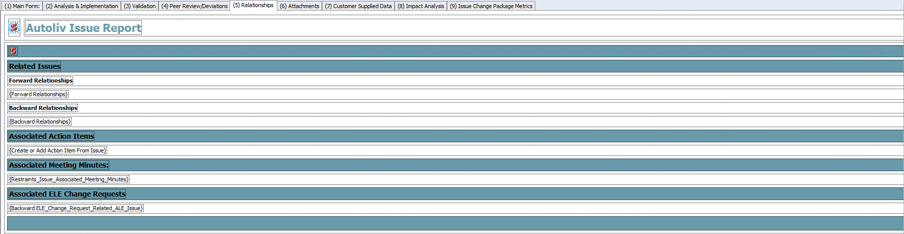

### “Attachments” tab:



### “Customer Supplied Data” tab:

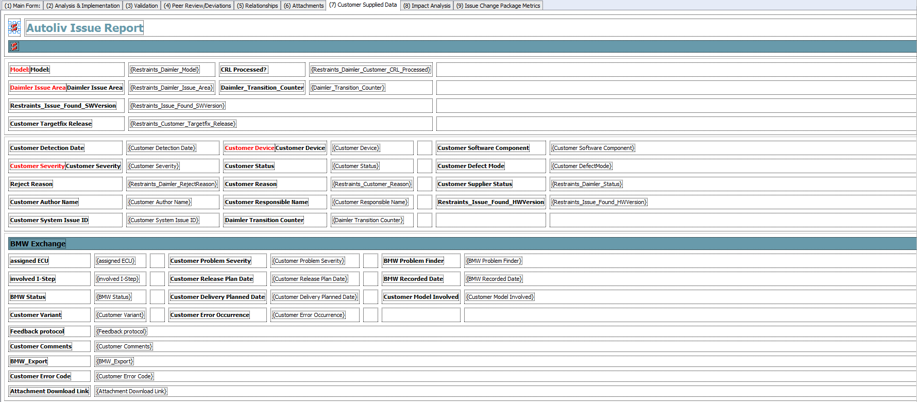

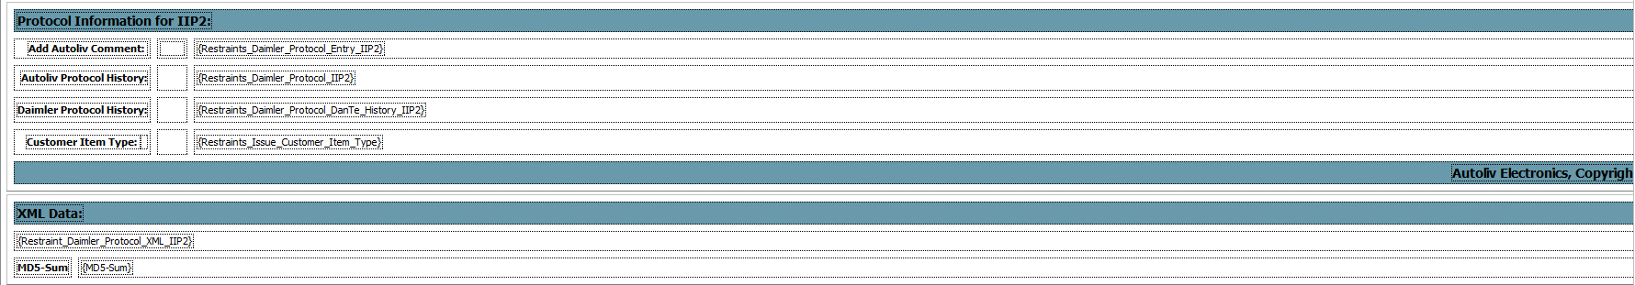

### “Impact Analysis” tab:



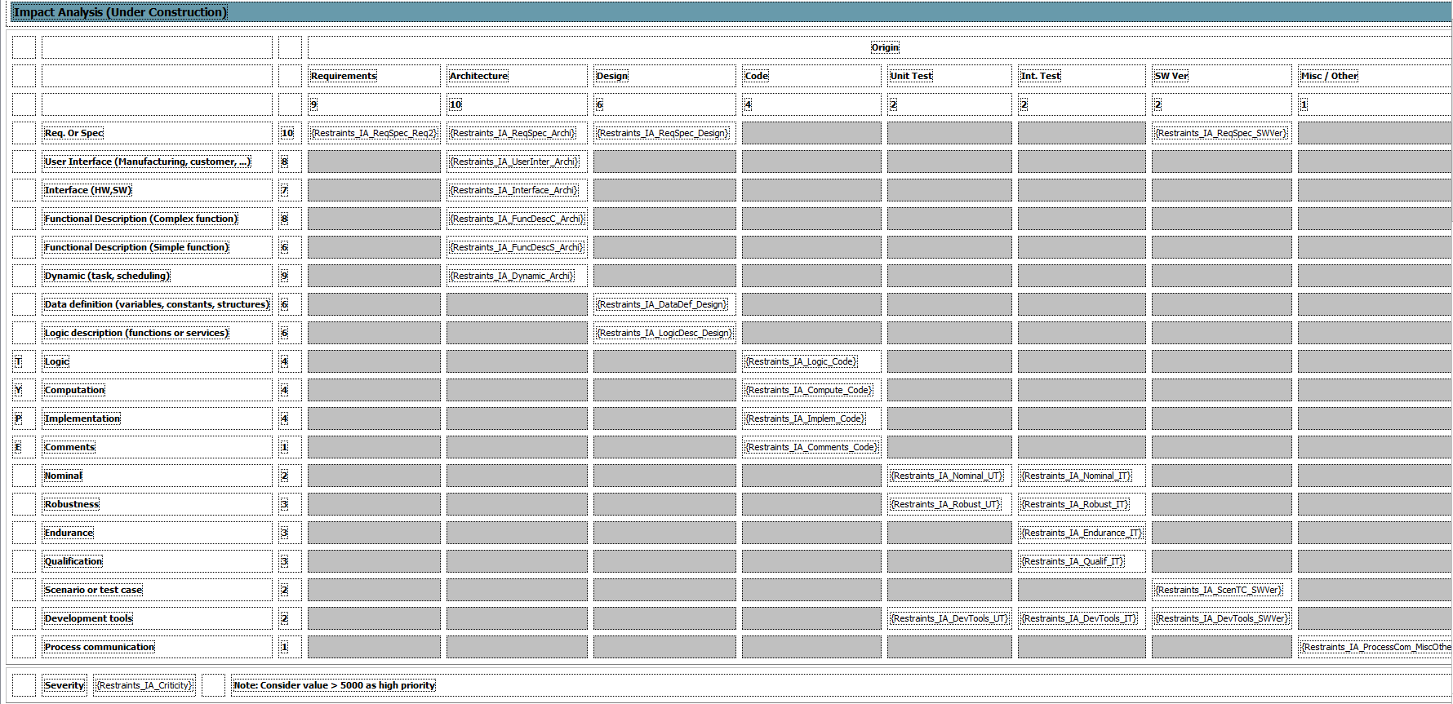

### “Issue Change Package Metrics” tab :

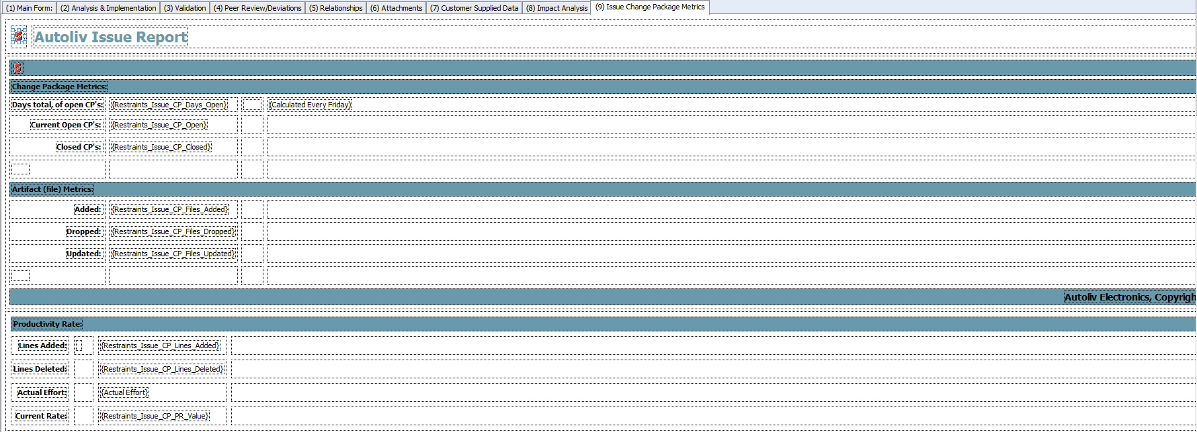

## Simplified workflow :

## List of **MANDATORY** attributes and when they must be entered and when they are visible:

|  |  |  |  |  |  |  |  |  |  |  |  |  |
| --- | --- | --- | --- | --- | --- | --- | --- | --- | --- | --- | --- | --- |
| PTC name | type | description | (Submitted) | (To Be Analyzed) | (Analyzed) | (To Be Implemented) | (Implemented) | (To Be Reviewed) | (Reviewed) | (To Be Verified) | (Verified) | (Closed) |
| **Assignee Analyze** | user |  |  | M | V | V | V | V | V | V | V | V |
| **Assignee Analyze Due Date** | date | Database name: "Assignee Analyze Due Date" |  | M | V | V | V | V | V | V | V | V |
| **Assignee Integrator** | user | Field that defines the engineer responsible for integration testing. |  |  |  |  |  | M | V | V | V | V |
| **Assignee Integrator Due Date** | date |  |  |  |  |  |  | M | V | V | V | V |
| **Assignee SW** | user |  |  |  |  | M | V | V | V | V | V | V |
| **Assignee SW Due Date** | date |  |  |  |  | M | V | V | V | V | V | V |
| **Issue Title** | shorttext | Title of the issue | M | V | V | V | V | V | V | V | V | V |
| **Issue Type** | pick | Is this a change or defect? | M | V | V | V | V | V | V | V | V | V |
| **Project** | project | The project affected of this change | M | V | V | V | V | V | V | V | V | V |
| **Restraints_Analysis** | longtext |  |  | V | V | V | V | V | V | V | V | V |
| **Restraints_Assignee_Analyze_Actual** | integer | The amount of hours it took to analyze an issue |  | V | M | V | V | V | V | V | V | V |
| **Restraints_Assignee_Analyze_Est** | integer | Estimate of how much effort it will take to analyse an issue |  | M | V | V | V | V | V | V | V | V |
| **Restraints_Assignee_Validation** | user |  |  |  |  | V | V | V | V | M | V | V |
| **Restraints_Code_Implementation_Effort_Actual** | integer | Amount of hours taken to complete code implementation for this issue. |  |  |  | V | M | V | V | V | V | V |
| **Restraints_Code_Implementation_Effort_Est** | integer | Restraints effort estimation to define how many hours to implement a coding change. |  |  | M | V | V | V | V | V | V | V |
| **Restraints_Code_Implementation_Peer_Review_Status** | pick | Select the current status of this step |  |  |  |  |  | V | M | V | V | V |
| **Restraints_Code_Implementation_Status** | pick | Select the current status of this step |  |  |  | V | M | V | V | V | V | V |
| **Restraints_Description** | longtext |  | M | V | V | V | V | V | V | V | V | V |
| **Restraints_Design_Specification_Effort_Actual** | integer | Actual hours needed to complete the design specification updates for this issue. |  |  |  | V | M | V | V | V | V | V |
| **Restraints_Design_Specification_Effort_Est** | integer | Estimate the amount of hours to complete this step |  |  | M | V | V | V | V | V | V | V |
| **Restraints_Design_Specification_Peer_Review_Status** | pick |  |  |  |  |  |  | V | M | V | V | V |
| **Restraints_Design_Specification_Status** | pick | Select the current status of this step |  |  |  | V | M | V | V | V | V | V |
| **Restraints_Integration_Effort_Act** | integer |  |  |  |  |  |  | V | M | V | V | V |
| **Restraints_Integration_Effort_Est** | integer |  |  |  |  |  |  | M | V | V | V | V |
| **Restraints_QAC_Analysis_Effort_Actual** | integer | Actual hours taken to complete QAC Analysis for this issue. |  |  |  | V | M | V | V | V | V | V |
| **Restraints_QAC_Analysis_Effort_Est** | integer | Estimate the amount of hours to complete this step |  |  | M | V | V | V | V | V | V | V |
| **Restraints_QAC_Analysis_Peer_Review_Status** | pick |  |  |  |  |  |  | V | M | V | V | V |
| **Restraints_QAC_Analysis_Status** | pick | Select the current status of this step |  |  |  | V | M | V | V | V | V | V |
| **Restraints_Release_Validated** | ibpl |  |  |  |  |  |  |  |  |  | M | V |
| **Restraints_Requirements_Traceability_Effort_Actual** | integer | Actual hours to complete requirements traceability for this issue. |  |  |  | V | M | V | V | V | V | V |
| **Restraints_Requirements_Traceability_Effort_Est** | integer | Estimate the amount of hours to complete this step |  |  | M | V | V | V | V | V | V | V |
| **Restraints_Requirements_Traceability_Peer_Review_Status** | pick |  |  |  |  |  |  | V | M | V | V | V |
| **Restraints_Requirements_Traceability_Status** | pick | If the approved task assumed |  |  |  | V | M | V | V | V | V | V |
| **Restraints_Target_Release_Container** | ibpl |  | V | V | V | M | V | V | V | V | V | V |
| **Restraints_Target_Software_Release** | ibpl |  | V | V | V | M | V | V | V | V | V | V |
| **Restraints_Unit_Test_Effort_Actual** | integer | Actual hours taken to complete unit testing for this issue. |  |  |  | V | M | V | V | V | V | V |
| **Restraints_Unit_Test_Effort_Est** | integer | Estimate the amount of hours to complete this step |  |  | M | V | V | V | V | V | V | V |
| **Restraints_Unit_Test_Peer_Review_Status** | pick |  |  |  |  |  |  | V | M | V | V | V |
| **Restraints_Unit_Test_Status** | pick | Select the current status of this step |  |  |  | V | M | V | V | V | V | V |
| **Restraints_Validation_Due_Date** | date |  |  |  |  | (V) | (V) | (V) | (V) | M | V | V |
| **Restraints_Validation_Result** | pick |  |  |  |  |  |  |  |  |  | M | V |

## List of **OPTIONAL (Visible)** attributes and when they must be entered and when they are visible:

|  |  |  |  |  |  |  |  |  |  |  |  |  |
| --- | --- | --- | --- | --- | --- | --- | --- | --- | --- | --- | --- | --- |
| PTC name | type | description | (Submitted) | (To Be Analyzed) | (Analyzed) | (To Be Implemented) | (Implemented) | (To Be Reviewed) | (Reviewed) | (To Be Verified) | (Verified) | (Closed) |
| **Assignee TEST** | user |  |  | V | V | V | V | V | V | V | V | V |
| **Assignee TEST Due Date** | date |  |  | (V) | (V) | (V) | (V) | (V) | (V) | (V) | (V) | (V) |
| **Customer Issue ID** | shorttext | If the Change/Error has been reported from customer, enter customer ID here | V | V | V | V | V | V | V | V | V | V |
| **Customer visible** | pick |  | V | V | V | V | V | V | V | V | V | V |
| **Keywords** | shorttext |  | V | V | V | V | V | V | V | V | V | V |
| **Observed during** | pick | Choose when in the developement chain the change/error was detected | V | V | V | V | V | V | V | V | V | V |
| **Requirement ID** | shorttext | If the error/change is connected to a requirement, enter the requirement ID here | V | V | V | V | V | V | V | V | V | V |
| **Restraints_Assignee_Analyze_Date_Complete** | date |  |  |  |  | V | V | V | V | V | V | V |
| **Restraints_CCB_Comments** | longtext |  | V | V | V | V | V | V | V | V | V | V |
| **Restraints_CCB_Responsible** | user |  | V | V | V | V | V | V | V | V | V | V |
| **Restraints_Code_Implementation_Comments** | longtext | Describe the details of this task:  1.) If not completed, define why.  2.) If completed, define location of supporting documentation. |  |  |  | V | V | V | V | V | V | V |
| **Restraints_Current_Eng_Assigned** | user | Restraints Issue Field. Used to track which engineer is currently assigned (working) the issue. Each step in the workflow has it's own assignee, this field sets who is assigned the issue based on the state. |  |  | V | V | V | V | V | V | V | V |
| **Restraints_Design_Specification_Comments** | longtext | Describe the details of this task:  1.) If not completed, define why.  2.) If completed, define location of supporting documentation. |  |  |  | V |  |  |  |  |  |  |
| **Restraints_Effort_Actual** | integer | Actual total hours to complete all steps for this issue. |  |  |  | V | V | V | V | V | V | V |
| **Restraints_Effort_Est** | integer | Estimate the amount of hours to complete this step |  |  | V | V | V | V | V | V | V | V |
| **Restraints_Global_Issue_Boolean** | logical |  | V | V | V | V | V | V | V | V | V | V |
| **Restraints_Implementation_Date_Complete** | date |  |  |  |  |  | V | V | V | V | V | V |
| **Restraints_Integration_Date_Complete** | date |  |  |  |  |  |  | V | V | V | V | V |
| **Restraints_Issue_age** | integer |  | V | V | V | V | V | V | V | V | V | V |
| **Restraints_Issue_Age_Status** | range |  | V | V | V | V | V | V | V | V | V | V |
| **Restraints_Issue_Change_Scope_Area** | pick | Used to define the areas of impact brought on by this change request. |  |  | V | V | V | V | V | V | V | V |
| **Restraints_Issue_Current_Effort_Actual** | integer | This issue's current state's actual effort (in hours) | V | V | V | V | V | V | V | V | V | V |
| **Restraints_Issue_Current_Effort_Est** | integer | This issue's current state's effort estimation (in hours) | V | V | V | V | V | V | V | V | V | V |
| **Restraints_Issue_Date_Complete** | date |  | V | V | V | V | V | V | V | V | V | V |
| **Restraints_Issue_Target_Build_Date** | fva |  |  | ? |  | V | V | V | V | V | V | V |
| **Restraints_Overall_Effort_Actual** | integer | Computes the overall actual effort (minus validation, which is not implemented) | V | V | V | V | V | V | V | V | V | V |
| **Restraints_Overall_Effort_Est** | integer | Computes the overall estimated effort for this issue. (does not yet contain validation estimates) | V | V | V | V | V | V | V | V | V | V |
| **Restraints_Overdue_Indicator** | range |  | V | V | V | V | V | V | V | V | V | V |
| **Restraints_QAC_Analysis_Comments** | longtext | Describe the details of this task:  1.) If not completed, define why.  2.) If completed, define location of supporting documentation. |  |  |  | V | V | V | V | V | V | V |
| **Restraints_Release_Issue_Found** | ibpl |  | V | V | V | V | V | V | V | V | V | V |
| **Restraints_Requirements_Traceability_Comments** | longtext | Describe the details of this task:  1.) If not completed, define why.  2.) If completed, define location of supporting documentation. |  |  |  | V | V | V | V | V | V | V |
| **Restraints_Severity** | pick | Select the Severity (Major, Minor, Change) Major - Any error in a software artifact which: a) causes a functional failure of the product or could be detected in operation. Minor - Any error in a software artifact which: a)cannot cause a functional failure of the product and cannot be detected in operation. Change - Change request |  | V | V | V | V | V | V | V | V | V |
| **Restraints_Unit_Test_Comments** | longtext | Describe the details of this task:  1.) If not completed, define why.  2.) If completed, define location of supporting documentation. |  |  |  | V | V | V | V | V | V | V |
| **Restraints_Validation_Change_Analysis_Complete_Date** | date |  |  |  | (V) | (V) | (V) | (V) | (V) | (V) | (V) | (V) |
| **Restraints_Validation_Change_Analysis_Effort_Actual** | integer | Actual hours to complete this task for this issue. |  | (V) | (V) | (V) | (V) | (V) | (V) | (V) | (V) | (V) |
| **Restraints_Validation_Change_Analysis_Effort_Est** | integer | Estimated hours to complete change analysis. |  | (V) | (V) | (V) | (V) | (V) | (V) | (V) | (V) | (V) |
| **Restraints_Validation_Change_Analysis_Status** | pick | Current status of this task. |  |  | (V) | (V) | (V) | (V) | (V) | (V) | (V) | (V) |
| **Restraints_Validation_Change_Implementation_Comments** | longtext |  |  |  |  | (V) | (V) | (V) | (V) | V | V | V |
| **Restraints_Validation_Change_Implementation_Effort_Actual** | integer | Actual hours to complete this task for this issue. |  |  |  | (V) | (V) | (V) | (V) | V | V | V |
| **Restraints_Validation_Change_Implementation_Effort_Est** | integer | Estimated hours to complete test case updates for this issue. | V | V | V | V | V | V | V | V | V | V |
| **Restraints_Validation_Change_Implementation_Peer_Review_Status** | pick | Current status of this task. |  |  |  | (V) | (V) | (V) | (V) | V | V | V |
| **Restraints_Validation_Change_Implementation_Status** | pick | Current status of this task. |  |  |  | (V) | (V) | (V) | (V) | V | V | V |
| **Restraints_Validation_Effort_Actual_Calc** | integer |  | ? |  |  | (V) | (V) | (V) | (V) | V | V | V |
| **Restraints_Validation_Effort_Est_Calc** | integer |  | ? |  |  | (V) | (V) | (V) | (V) | V | V | V |
| **Restraints_Validation_Test_Execution_Comments** | longtext |  |  |  |  | (V) | (V) | (V) | (V) | V | V | V |
| **Restraints_Validation_Test_Execution_Effort_Actual** | integer | Actual time to complete this task for this issue. |  |  |  | (V) | (V) | (V) | (V) | V | V | V |
| **Restraints_Validation_Test_Execution_Effort_Est** | integer | Estimated hours to complete the test execution for this issue. | V | V | V | V | V | V | V | V | V | V |
| **Restraints_Validation_Test_Execution_Peer_Review_Status** | pick |  |  |  |  | (V) | (V) | (V) | (V) | V | V | V |
| **Restraints_Validation_Test_Execution_Status** | pick | Current Status for this task. |  |  |  | (V) | (V) | (V) | (V) | V | V | V |
| **Restraints_Workload_Priority** | integer |  | V | V | V | V | V | V | V | V | V | V |
| **State** | state | Select the next state (the state you want to send the issue to) | V | V | V | V | V | V | V | V | V | V |
| **Verification_Validation** | longtext | Describe how the issue shall be verified or validated. | V | V | V | V | V | V | V | V | V | V |

## List of **OTHER** attributes (Most are not used and not visible):

|  |  |  |  |  |  |  |  |  |  |  |  |  |
| --- | --- | --- | --- | --- | --- | --- | --- | --- | --- | --- | --- | --- |
| PTC name | type | description | (Submitted) | (To Be Analyzed) | (Analyzed) | (To Be Implemented) | (Implemented) | (To Be Reviewed) | (Reviewed) | (To Be Verified) | (Verified) | (Closed) |
| **ALE_DM_Relationship** | relationship |  |  |  |  |  |  |  |  |  |  |  |
| **Backward ELE_Change_Request_Related_ALE_Issue** | relationship | Used to link ELE Change Requests to ALE Issue Report v1.1 |  |  |  |  |  |  |  |  |  |  |
| **Bookmarks** | longtext | Information about bookmarks stored in the rich text fields on an item. |  |  |  |  |  |  |  |  |  |  |
| **Created By** | user |  |  |  |  |  |  |  |  |  |  |  |
| **Created Date** | date |  |  |  |  |  |  |  |  |  |  |  |
| **ID** | integer |  |  |  |  |  |  |  |  |  |  |  |
| **Integration Date** | date |  |  |  |  |  |  |  |  |  |  |  |
| **Issue Completion Date** | date |  |  |  |  |  |  |  |  |  |  |  |
| **Live Item ID** | integer | Live Item ID. Normally the same as the ID field; unless an item was versioned, in which case the ID field will be a unique identifier representing a static copy of a particular version of the item. If the Live Item ID is equal to the ID, then the item is live. |  |  |  |  |  |  |  |  |  |  |
| **Major Version ID** | integer | Major Version ID. This is empty if the item is live and has not been versioned. If the item is versioned, this is the major increment number (for example, the major increment number of version 2.3 is 2). |  |  |  |  |  |  |  |  |  |  |
| **Minor Version ID** | integer | Minor Version ID. This is empty if the item is live and has not been versioned. If the item is versioned, this is the minor increment number (for example, the minor increment number of version 2.3 is 3). |  |  |  |  |  |  |  |  |  |  |
| **Modified By** | user |  |  |  |  |  |  |  |  |  |  |  |
| **Modified Date** | date |  |  |  |  |  |  |  |  |  |  |  |
| **Restraint_Daimler_Protocol_XML_IIP2** | longtext | XML data to send over to the Daimler DanTe server - built with a trigger |  |  |  |  |  |  |  |  |  |  |
| **Restraints_assigned_ECU** | pick |  |  |  |  |  |  |  |  |  |  |  |
| **Restraints_Assignee_Analyze_Complete_Date** | date |  |  |  |  |  |  |  |  |  |  |  |
| **Restraints_Assignee_Analyze_Planned_Start_Date** | date | Restraints solutions planned start date in order to complete analysis on time. |  |  |  |  |  |  |  |  |  |  |
| **Restraints_Assignee_Analyze_Status** | pick |  |  |  |  |  |  |  |  |  |  |  |
| **Restraints_Assignee_Code_Planned_Start_Date** | date | Suggested start date for this step. |  |  |  |  |  |  |  |  |  |  |
| **Restraints_Assignee_Design_Planned_Start_Date** | date | Suggested start date for this step. |  |  |  |  |  |  |  |  |  |  |
| **Restraints_Assignee_QAC_Planned_Start_Date** | date | Suggested start date for this step. |  |  |  |  |  |  |  |  |  |  |
| **Restraints_Assignee_Requirements_Planned_Start_Date** | date | Suggested start date for this step. |  |  |  |  |  |  |  |  |  |  |
| **Restraints_Assignee_Unit_Test_Planned_Start_Date** | date | Suggested start date for this step. |  |  |  |  |  |  |  |  |  |  |
| **Restraints_Attachment_Download_Link** | longtext |  |  |  |  |  |  |  |  |  |  |  |
| **Restraints_BMW_Export** | longtext | BMW export from BMW-QC System for Problem category, affected ECU and Target I-Step |  |  |  |  |  |  |  |  |  |  |
| **Restraints_BMW_Problem_Finder** | shorttext |  |  |  |  |  |  |  |  |  |  |  |
| **Restraints_BMW_Recorded_Date** | shorttext |  |  |  |  |  |  |  |  |  |  |  |
| **Restraints_BMW_Status** | shorttext |  |  |  |  |  |  |  |  |  |  |  |
| **Restraints_Code_Implementation_Complete_Date** | date |  |  |  |  |  |  |  |  |  |  |  |
| **Restraints_Code_Implementation_Peer_Review_Complete_Date** | date | Replaces: Restraints_Code_Implementation_Peer_Review_Date_Complete |  |  |  |  |  |  |  |  |  |  |
| **Restraints_CONST_CCB_Interval** | integer |  |  |  |  |  |  |  |  |  |  |  |
| **Restraints_CONST_Postponed_Overdue_Max** | integer |  |  |  |  |  |  |  |  |  |  |  |
| **Restraints_Customer_AuthorName** | shorttext | Restraints Customer Responsible Name - Field for IIP2 created for Daimler Interface |  |  |  |  |  |  |  |  |  |  |
| **Restraints_Customer_Comments** | longtext | Comments from BMW |  |  |  |  |  |  |  |  |  |  |
| **Restraints_Customer_DefectMode** | shorttext | Restraints Customer DefectMode - Field for IIP2 created for Daimler Interface |  |  |  |  |  |  |  |  |  |  |
| **Restraints_Customer_Delivery_Planned_Date** | date | planned customer delivery date |  |  |  |  |  |  |  |  |  |  |
| **Restraints_Customer_Detection_Date** | date |  |  |  |  |  |  |  |  |  |  |  |
| **Restraints_Customer_Device** | pick |  |  |  |  |  |  |  |  |  |  |  |
| **Restraints_Customer_Error_Code** | longtext | ECU error code |  |  |  |  |  |  |  |  |  |  |
| **Restraints_Customer_Error_Occurrence** | pick |  |  |  |  |  |  |  |  |  |  |  |
| **Restraints_Customer_Model_Involved** | pick | BMW Lead Model and Model involved information. |  |  |  |  |  |  |  |  |  |  |
| **Restraints_Customer_Problem_Severity** | pick |  |  |  |  |  |  |  |  |  |  |  |
| **Restraints_Customer_Reason** | shorttext | Fields Restraints_Customer_Reason created for IIP exchange with Daimler |  |  |  |  |  |  |  |  |  |  |
| **Restraints_Customer_Release_Plan_Date** | date | Date when BMW needs solution from Autoliv. |  |  |  |  |  |  |  |  |  |  |
| **Restraints_Customer_ResponsibleName** | shorttext | Restraints Customer Responsible Name - Field for IIP2 created for Daimler Interface |  |  |  |  |  |  |  |  |  |  |
| **Restraints_Customer_Severity** | pick |  |  |  |  |  |  |  |  |  |  |  |
| **Restraints_Customer_Software_Component** | pick |  |  |  |  |  |  |  |  |  |  |  |
| **Restraints_Customer_Status** | pick |  |  |  |  |  |  |  |  |  |  |  |
| **Restraints_Customer_System_Issue_ID** | shorttext |  |  |  |  |  |  |  |  |  |  |  |
| **Restraints_Customer_Targetfix_Release** | longtext | Field added to ALE Restraints workflow to support the MIIP server and Daimler. |  |  |  |  |  |  |  |  |  |  |
| **Restraints_Customer_to_be _updated** | logical | Used to determine whether or not we need to transfer this item over to the DanTe system |  |  |  |  |  |  |  |  |  |  |
| **Restraints_Customer_Variant** | pick | According to BMW there are no variants planned for REMA4-AS. Variants may come at a later date or ECU, so pick list dont have any values yet. |  |  |  |  |  |  |  |  |  |  |
| **Restraints_Daimler_ALV_Comments_Added** | pick | Used to correct MIIP transfer problem (information was re-written in Protocols fields each time a transfer occurs). If the field "Restraints_CCB_Comments" field is edited by a Autoliv employee, this field will be set to Yes by the corresponding trigger. The automatic exchange software on the MIIP server will set the value to No after a data exchange from MKS to Dan Te. |  |  |  |  |  |  |  |  |  |  |
| **Restraints_Daimler_Customer_CRL_Processed** | logical | Field used with IIP data exchange - used to specify customer CRL processed 'yes' or 'no' answer. |  |  |  |  |  |  |  |  |  |  |
| **Restraints_Daimler_Is_IIP_exchanged** | logical |  |  |  |  |  |  |  |  |  |  |  |
| **Restraints_Daimler_Issue_Area** | pick | Field added to support ALE Restraints workflow to support the MIIP server and Daimler. |  |  |  |  |  |  |  |  |  |  |
| **Restraints_Daimler_Model** | pick | Field added to the ALE Restraints workflow to suppor the MIIP server and Daimler. |  |  |  |  |  |  |  |  |  |  |
| **Restraints_Daimler_Model_Show_Label_Mandatory_No** | logical |  |  |  |  |  |  |  |  |  |  |  |
| **Restraints_Daimler_Model_Show_Label_Mandatory_Yes** | logical |  |  |  |  |  |  |  |  |  |  |  |
| **Restraints_Daimler_Protocol_DanTe_History_IIP2** | longtext | Lists the entire Protocol history from the DanTe/Diamler system |  |  |  |  |  |  |  |  |  |  |
| **Restraints_Daimler_Protocol_Entry_IIP2** | longtext | Used by the user to enter in new messages to the IIP2 protocol field. |  |  |  |  |  |  |  |  |  |  |
| **Restraints_Daimler_Protocol_IIP2** | longtext | This is the DanTe protocol field. |  |  |  |  |  |  |  |  |  |  |
| **Restraints_Daimler_RejectReason** | pick |  |  |  |  |  |  |  |  |  |  |  |
| **Restraints_Daimler_Status** | longtext | Added to the workflow to support the MIIP server efforts with Daimler. |  |  |  |  |  |  |  |  |  |  |
| **Restraints_Daimler_Transition_Counter** | integer |  |  |  |  |  |  |  |  |  |  |  |
| **Restraints_Days_In_State_Analyzed** | integer |  |  |  |  |  |  |  |  |  |  |  |
| **Restraints_Days_In_State_Closed** | integer |  |  |  |  |  |  |  |  |  |  |  |
| **Restraints_Days_In_State_Implemented** | integer |  |  |  |  |  |  |  |  |  |  |  |
| **Restraints_Days_In_State_Integrated** | integer |  |  |  |  |  |  |  |  |  |  |  |
| **Restraints_Days_In_State_Postponed** | integer |  |  |  |  |  |  |  |  |  |  |  |
| **Restraints_Days_In_State_Rejected** | integer |  |  |  |  |  |  |  |  |  |  |  |
| **Restraints_Days_In_State_Submitted** | integer |  |  |  |  |  |  |  |  |  |  |  |
| **Restraints_Days_In_State_To_Be_Analyzed** | integer |  |  |  |  |  |  |  |  |  |  |  |
| **Restraints_Days_In_State_To_Be_Implemented** | integer |  |  |  |  |  |  |  |  |  |  |  |
| **Restraints_Days_In_State_To_Be_Verified** | integer |  |  |  |  |  |  |  |  |  |  |  |
| **Restraints_Days_In_State_Verified** | integer |  |  |  |  |  |  |  |  |  |  |  |
| **Restraints_Design_Specification_Complete_Date** | date | Replaces: Restraints_Design_Specification_Date_Complete |  |  |  |  |  |  |  |  |  |  |
| **Restraints_Design_Specification_Peer_Review_Complete_Date** | date | Replaces: Restraints_Design_Specification_Peer_Review_Date_Complete |  |  |  |  |  |  |  |  |  |  |
| **Restraints_Diamler_Customer_MultipleWorkflowParentID** | shorttext | Added to support the IIP services with Diamler. |  |  |  |  |  |  |  |  |  |  |
| **Restraints_Edit_All_Issues_Switch** | integer | used to modify ever issue assigned - allows for 'mass' edit of all issues when needed. |  |  |  |  |  |  |  |  |  |  |
| **Restraints_Edit_Mode** | logical |  |  |  |  |  |  |  |  |  |  |  |
| **Restraints_Feedback_protocol** | longtext | Autoliv comments regarding the defect (Solution description, Root Cause, General Comments) |  |  |  |  |  |  |  |  |  |  |
| **Restraints_Filtered_Release** | shorttext |  |  |  |  |  |  |  |  |  |  |  |
| **Restraints_IA_Comments_Code** | pick |  |  |  |  |  |  |  |  |  |  |  |
| **Restraints_IA_Compute_Code** | pick |  |  |  |  |  |  |  |  |  |  |  |
| **Restraints_IA_Criticity** | integer |  |  |  |  |  |  |  |  |  |  |  |
| **Restraints_IA_DataDef_Design** | pick |  |  |  |  |  |  |  |  |  |  |  |
| **Restraints_IA_DevTools_IT** | pick |  |  |  |  |  |  |  |  |  |  |  |
| **Restraints_IA_DevTools_SWVer** | pick |  |  |  |  |  |  |  |  |  |  |  |
| **Restraints_IA_DevTools_UT** | pick |  |  |  |  |  |  |  |  |  |  |  |
| **Restraints_IA_Dynamic_Archi** | pick |  |  |  |  |  |  |  |  |  |  |  |
| **Restraints_IA_Endurance_IT** | pick |  |  |  |  |  |  |  |  |  |  |  |
| **Restraints_IA_FuncDescC_Archi** | pick |  |  |  |  |  |  |  |  |  |  |  |
| **Restraints_IA_FuncDescS_Archi** | pick |  |  |  |  |  |  |  |  |  |  |  |
| **Restraints_IA_Implem_Code** | pick |  |  |  |  |  |  |  |  |  |  |  |
| **Restraints_IA_Interface_Archi** | pick |  |  |  |  |  |  |  |  |  |  |  |
| **Restraints_IA_Logic_Code** | pick |  |  |  |  |  |  |  |  |  |  |  |
| **Restraints_IA_LogicDesc_Design** | pick |  |  |  |  |  |  |  |  |  |  |  |
| **Restraints_IA_Nominal_IT** | pick |  |  |  |  |  |  |  |  |  |  |  |
| **Restraints_IA_Nominal_UT** | pick |  |  |  |  |  |  |  |  |  |  |  |
| **Restraints_IA_ProcessCom_MiscOther** | pick |  |  |  |  |  |  |  |  |  |  |  |
| **Restraints_IA_Qualif_IT** | pick |  |  |  |  |  |  |  |  |  |  |  |
| **Restraints_IA_ReqSpec_Archi** | pick |  |  |  |  |  |  |  |  |  |  |  |
| **Restraints_IA_ReqSpec_Design** | pick |  |  |  |  |  |  |  |  |  |  |  |
| **Restraints_IA_ReqSpec_Req2** | pick |  |  |  |  |  |  |  |  |  |  |  |
| **Restraints_IA_ReqSpec_SWVer** | pick |  |  |  |  |  |  |  |  |  |  |  |
| **Restraints_IA_Robust_IT** | pick |  |  |  |  |  |  |  |  |  |  |  |
| **Restraints_IA_Robust_UT** | pick |  |  |  |  |  |  |  |  |  |  |  |
| **Restraints_IA_ScenTC_SWVer** | pick |  |  |  |  |  |  |  |  |  |  |  |
| **Restraints_IA_UserInter_Archi** | pick |  |  |  |  |  |  |  |  |  |  |  |
| **Restraints_Implementation_Complete (Old)** | date | Completion date of this development step |  |  |  |  |  |  |  |  |  |  |
| **Restraints_involved_I-Step** | shorttext | This field is used with default value of involved i-steps for BMW exchange. |  |  |  |  |  |  |  |  |  |  |
| **Restraints_Issue_Associated_Meeting_Minutes** | relationship | Allows a link between this issue and meeting minutes in the system. |  |  |  |  |  |  |  |  |  |  |
| **Restraints_Issue_Change_Impact_Description_Soft_Arch_Unit_Test** | shorttext | Description field for the software atomic architectural unit test step. |  |  |  |  |  |  |  |  |  |  |
| **Restraints_Issue_Change_Impact_Description_Software_Architecture_Design** | shorttext | Defines the impact to Requirements due to this change request. |  |  |  |  |  |  |  |  |  |  |
| **Restraints_Issue_Change_Impact_Description_Software_Atomic_Architecture_Unit** | shorttext | Defines the impact on Software Atomic Architecture Unit for this change request |  |  |  |  |  |  |  |  |  |  |
| **Restraints_Issue_Change_Impact_Description_Software_Integration** | shorttext | Description of the Software Integration needed for this issue. |  |  |  |  |  |  |  |  |  |  |
| **Restraints_Issue_Change_Impact_Description_Software_Requirements** | shorttext | Defines the impact of this change request to the software requirements. |  |  |  |  |  |  |  |  |  |  |
| **Restraints_Issue_Change_Impact_Description_Software_Validation** | shorttext | Defines the Software Validation adjustments needed for this issue. |  |  |  |  |  |  |  |  |  |  |
| **Restraints_Issue_Change_Impact_Description_Software_Verification** | shorttext | Defines the Software Verification required for this issue. |  |  |  |  |  |  |  |  |  |  |
| **Restraints_Issue_Change_Impact_Description_Source_Code** | shorttext | Description of the source code changes needed for this issue. |  |  |  |  |  |  |  |  |  |  |
| **Restraints_Issue_Consists_of_Action_Items** | relationship |  |  |  |  |  |  |  |  |  |  |  |
| **Restraints_Issue_Consists_of_Deviations** | relationship |  |  |  |  |  |  |  |  |  |  |  |
| **Restraints_Issue_Consists_of_Peer_Reviews** | relationship |  |  |  |  |  |  |  |  |  |  |  |
| **Restraints_Issue_CP_Closed** | integer | Calculates change package information |  |  |  |  |  |  |  |  |  |  |
| **Restraints_Issue_CP_Days_Open** | integer | Calculates change package information |  |  |  |  |  |  |  |  |  |  |
| **Restraints_Issue_CP_Files_Added** | integer | Calculates change package information |  |  |  |  |  |  |  |  |  |  |
| **Restraints_Issue_CP_Files_Dropped** | integer | Calculates change package information |  |  |  |  |  |  |  |  |  |  |
| **Restraints_Issue_CP_Files_Updated** | integer | Calculates change package information |  |  |  |  |  |  |  |  |  |  |
| **Restraints_Issue_CP_Lines_Added** | integer | Calculates change package information |  |  |  |  |  |  |  |  |  |  |
| **Restraints_Issue_CP_Lines_Deleted** | integer | Calculates change package information |  |  |  |  |  |  |  |  |  |  |
| **Restraints_Issue_CP_Open** | integer | Calculates change package information |  |  |  |  |  |  |  |  |  |  |
| **Restraints_Issue_CP_PR_Value** | integer | Productivity Rate for this issue |  |  |  |  |  |  |  |  |  |  |
| **Restraints_Issue_Current_Phase_Status** | pick |  |  |  |  |  |  |  |  |  |  |  |
| **Restraints_Issue_Customer_Item_Type** | shorttext |  |  |  |  |  |  |  |  |  |  |  |
| **Restraints_Issue_Derived_From_Release_Candidate** | relationship |  |  |  |  |  |  |  |  |  |  |  |
| **Restraints_Issue_Derived_From_Release_Container** | relationship |  |  |  |  |  |  |  |  |  |  |  |
| **Restraints_Issue_Effort_Est_Before_Assignment** | pick | At the issue level, determine if effort estimation has been provided before assignment to a candidate. This value will be used by the candidate to determine candidate health/status. |  |  |  |  |  |  |  |  |  |  |
| **Restraints_Issue_Found_HWVersion** | longtext | Field added to the ALE Restraints workflow to support the MIIP server and Daimler. |  |  |  |  |  |  |  |  |  |  |
| **Restraints_Issue_Found_SWVersion** | longtext | Field added to ALE Restraints workflow to support the MIIP server and Daimler. |  |  |  |  |  |  |  |  |  |  |
| **Restraints_Issue_is_Part_of_ISS** | relationship |  |  |  |  |  |  |  |  |  |  |  |
| **Restraints_Issue_Peer_Review_Held** | logical | Displays whether or not a peer review has been held for this item. |  |  |  |  |  |  |  |  |  |  |
| **Restraints_Issue_Safety_Case_Impact** | pick | Available in the ALE Issue v1.1 workflow - used to define impact for safety on issues. |  |  |  |  |  |  |  |  |  |  |
| **Restraints_Issue_Target_Start_Date** | fva |  |  |  |  |  |  |  |  |  |  |  |
| **Restraints_Issues_Current_Phase** | pick | Displays the current phase: Analysis, Development, Integration, Verification, or complete. |  |  |  |  |  |  |  |  |  |  |
| **Restraints_MD5-Sum** | longtext |  |  |  |  |  |  |  |  |  |  |  |
| **Restraints_Member_Moved** | logical |  |  |  |  |  |  |  |  |  |  |  |
| **Restraints_Overdue_Analyzed** | logical |  |  |  |  |  |  |  |  |  |  |  |
| **Restraints_Overdue_Implemented** | logical |  |  |  |  |  |  |  |  |  |  |  |
| **Restraints_Overdue_Int** | integer |  |  |  |  |  |  |  |  |  |  |  |
| **Restraints_Overdue_Integrated** | logical |  |  |  |  |  |  |  |  |  |  |  |
| **Restraints_Overdue_Issue** | logical |  |  |  |  |  |  |  |  |  |  |  |
| **Restraints_Overdue_Postponed** | logical |  |  |  |  |  |  |  |  |  |  |  |
| **Restraints_Overdue_Submitted** | logical |  |  |  |  |  |  |  |  |  |  |  |
| **Restraints_Overdue_To_Be_Analyzed** | logical |  |  |  |  |  |  |  |  |  |  |  |
| **Restraints_Overdue_To_Be_Implemented** | logical |  |  |  |  |  |  |  |  |  |  |  |
| **Restraints_Overdue_To_Be_Verified** | logical |  |  |  |  |  |  |  |  |  |  |  |
| **Restraints_Overdue_Verified** | logical |  |  |  |  |  |  |  |  |  |  |  |
| **Restraints_Owner** | user |  |  |  |  |  |  |  |  |  |  |  |
| **Restraints_QAC_Analysis_Complete_Date** | date | Replaces: Restraints_QAC_Analysis_Date_Complete |  |  |  |  |  |  |  |  |  |  |
| **Restraints_QAC_Analysis_Peer_Review_Complete_Date** | date | Replaces: Restraints_QAC_Analysis_Peer_Review_Date_Complete |  |  |  |  |  |  |  |  |  |  |
| **Restraints_Reject_Reason_OLD** | pick | Please use Restraints_Daimler_RejectReason field instead for IIP workflow |  |  |  |  |  |  |  |  |  |  |
| **Restraints_Release_Candidate_Name_Computed** | shorttext |  |  |  |  |  |  |  |  |  |  |  |
| **Restraints_Release_Container_Name_Computed** | shorttext |  |  |  |  |  |  |  |  |  |  |  |
| **Restraints_Release_Issue_Found_Mandatory_No** | logical |  |  |  |  |  |  |  |  |  |  |  |
| **Restraints_Release_Issue_Found_Mandatory_Yes** | logical |  |  |  |  |  |  |  |  |  |  |  |
| **Restraints_Requirements_Traceability_Complete_Date** | date | Replaces: Restraints_Requirements_Traceability_Date_Complete |  |  |  |  |  |  |  |  |  |  |
| **Restraints_Requirements_Traceability_Peer_Review_Complete_Date** | date | Replaces: Restraints_Requirements_Traceability_Peer_Review_Date_Complete |  |  |  |  |  |  |  |  |  |  |
| **Restraints_SW_Val** | user |  |  |  |  |  |  |  |  |  |  |  |
| **Restraints_Unit_Test_Complete_Date** | date | Replaces: Restraints_Unit_Test_Date_Complete |  |  |  |  |  |  |  |  |  |  |
| **Restraints_Unit_Test_Peer_Review_Complete_Date** | date | Replaces: Restraints_Unit_Test_Peer_Review_Date_Complete |  |  |  |  |  |  |  |  |  |  |
| **Restraints_Validation_Change_Implementation_Complete_Date** | date |  |  |  |  |  |  |  |  |  |  |  |
| **Restraints_Validation_Change_Implementation_Peer_Review_Complete_Date** | date |  |  |  |  |  |  |  |  |  |  |  |
| **Restraints_Validation_Complete (Old)** | date |  |  |  |  |  |  |  |  |  |  |  |
| **Restraints_Validation_Date_Complete** | date |  |  |  |  |  |  |  |  |  |  |  |
| **Restraints_Validation_Test_Execution_Complete_Date** | date |  |  |  |  |  |  |  |  |  |  |  |
| **Restraints_Validation_Test_Execution_Peer_Review_Complete_Date** | date |  |  |  |  |  |  |  |  |  |  |  |
| **Signature Comment** | shorttext |  |  |  |  |  |  |  |  |  |  |  |
| **Signed By** | user |  |  |  |  |  |  |  |  |  |  |  |
| **Summary** | shorttext | Describe the issue (actual behaviour vs expected behaviour), the request (target) |  |  |  |  |  |  |  |  |  |  |
| **Type** | type |  |  |  |  |  |  |  |  |  |  |  |